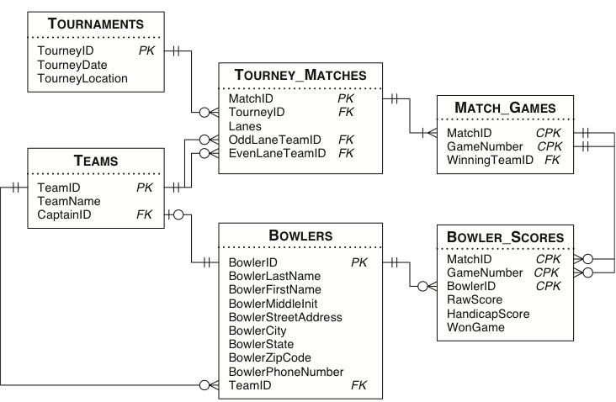
- Display name, and highest raw scores of bowlers who has highest raw scores greater than 150 (1 point)
- Display the first name, last name, and average raw scores of ‘Dolphins’ team members who has average raw scores greater than 150 (1 point)
- Display the first name, last name, and average raw scores of ‘Dolphins’ team members who has average raw scores greater than average raw scores of all bowlers (1 point)
- List the bowlers whose highest raw scores are at least 20 points higher than their current average (1 point)
- Show the team played either in odd lane or even lane. Note: You must use UNION to get credit (1 point)
- Find the winning team name for each match (Note: the winning team is the team won 2 games for each match) (1 point)
- Show the MVP bowlers’ first name, last name, team name, and match ID for each match. MVP bowlers are the one scored highest raw score of each match in the winning team (Note: the winning team is the team won 2 games for each match) (1 point)
- List team captains who has raw score that is higher than average of other members on the team (1 point)

